Nathan Baker Pacific Northwest National Laboratory

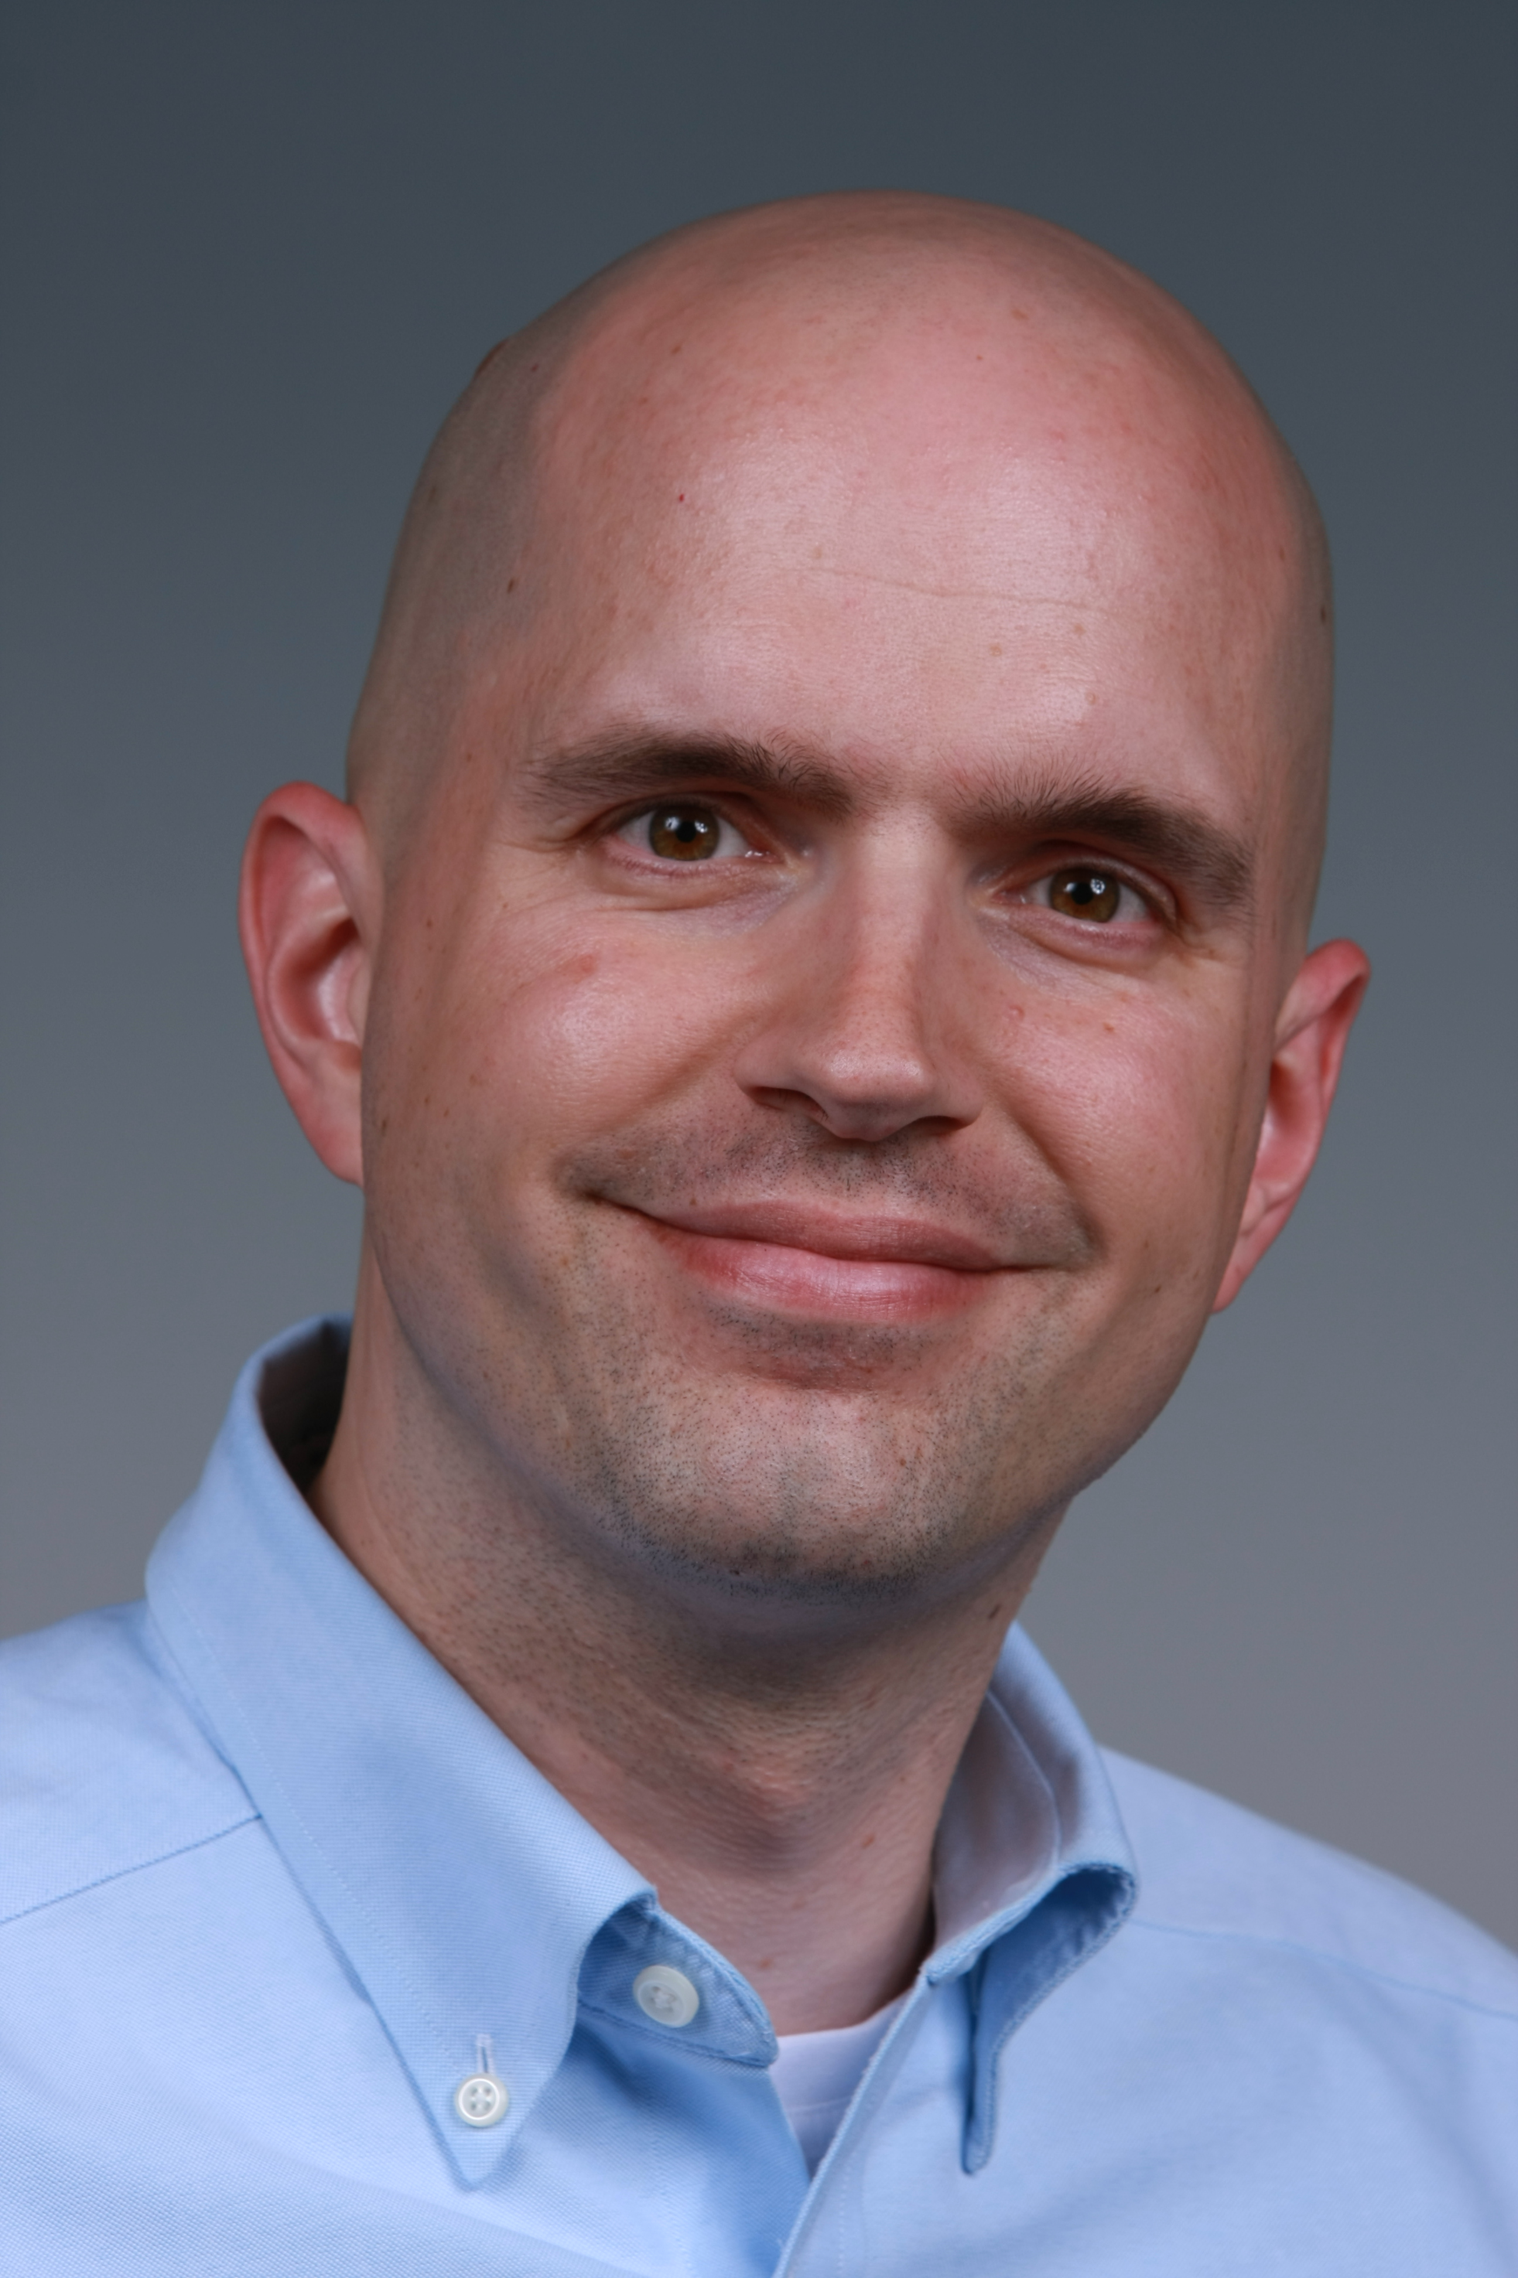

Laboratory Fellow

Areas of Responsibility

*Computational design of peptoids and b-peptides based on machine learning tools applied to aquaporin*

Qualifications Summary

* Lead for the Signature Discovery Initiative, a $16M PNNL internal investment in machine learning and related signature discovery methods
* Co-PI and Project Manager for the Collaboratory on Mathematics for Mesoscopic Modeling of Materials (CM4), a $6M DOE ASCR project on mesoscale modeling.
* 15+ years of experience on computational methods and applications in solvation and biomolecular modeling

Education and Training

2001-2002 Postdoc, Computational Biology, Univ. California San Diego

2001 PhD, Physical Chemistry, Univ. California San Diego

1997 BS with honors, Chemistry, Univ. Iowa

Research and Professional Experience

Laboratory Fellow, Computational and Statistical Analytics Division, PNNL (2012-present). Lead for Signature Discovery Initiative, co-PI for DOE ASCR CM4, PI and co-PI for several NIH projects on biomolecular modeling.

Chief Scientist, Computational and Statistical Analytics Division, PNNL (2010-2012). Lead for Signature Discovery Initiative, PI and co-PI for several NIH projects on biomolecular modeling.

Associate Professor (tenured), Washington Univ. St Louis, Dept. of Biochemistry and Molecular Biophysics (2006-2010). Director of PhD program in Molecular Biophysics, PI and co-PI for several NIH projects on biomolecular modeling and computational biology.

Assistant Professor, Washington Univ. St Louis, Dept. of Biochemistry and Molecular Biophysics (2002-2006). PI and co-PI for several NIH and NSF projects on biomolecular modeling and computational biology.

Publications and software (selected from over 75 total publications)

1. APBS & PDB2PQR (<http://www.poissonboltzmann.org/>). Implicit solvation software with over 20,000 users worldwide.
2. Gosink LJ, Hogan EA, Pulsipher TC, Baker NA. Bayesian model aggregation for ensemble-based estimates of protein p*Ka* values. *Proteins*, in press, 10.1002/prot.24390
3. Baker NA, Barr JL, Bonheyo GT, Joslyn CA, Krishnaswami K, Oxley ME, Quadrel R, Sego LH, Tardiff MF, Wynne AS.  Research towards a systematic signature discovery process.  *IEEE Intelligence and Security Informatics Signature Discovery Workshop*, 301–308, 2013. 10.1109/ISI.2013.6578848
4. Lee S-J, Schlesinger PH, Wickline SA, Lanza GM, Baker NA. Simulation of fusion-mediated nanoemulsion interactions with model lipid bilayers. *Soft Matter*, **8**, 7024-7025, 2012.
5. Ren P, Chun J, Thomas DG, Schnieders MJ, Marucho M, Zhang J, Baker NA. Biomolecular electrostatics and solvation: a computational perspective. *Quart Rev Biophys*, **45**, 427-491, 2012.
6. Chen Z, Zhao S, Chun J, Thomas DG, Baker NA, Bates PW, Wei GW. Variational approach for nonpolar solvation analysis. *J Chem Phys*, **137**, 084101, 2012
7. Lee S-J, Schlesinger PH, Wickline SA, Lanza GM, Baker NA. Interaction of Melittin Peptides with Perfluorocarbon Nanoemulsion Particles.  *J Phys Chem B*, **115**, 15271-15279, 2012
8. Olsen BN, Schlesinger PH, Baker NA. Perturbations of membrane structure by cholesterol and cholesterol derivatives are determined by sterol orientation. *J Am Chem Soc*, **131**, 4854-65, 2009
9. Bradley MJ, Chivers PT, Baker NA. Molecular dynamics simulation of the Escherichia coli NikR protein: Equilibrium conformational fluctuations reveal inter-domain allosteric communication pathways. *J Mol Biol*, **378**, 1155-73, 2008
10. Wagoner JA, Baker NA. Assessing implicit models for nonpolar mean solvation forces: the importance of dispersion and volume terms. *Proc Natl Acad Sci USA*, **103**, 8331-6, 2006

Synergistic Activities

* Editor-in-Chief of *Computational Science and Discovery*
* Editorial Board member of *Biophysical Journal*
* Co-chair, US-EU Community of Research for Nanotechnology Databases and Ontology (US OSTP)
* Fellow of the American Association for the Advancement of Science
* Alfred P. Sloan Fellow

Identification of Potential COI or Bias in Selection of Reviewers *[provide the following information]:*

* Collaborators and Co-Editors: Emil Alexov (Clemson Univ), Paul Atzberger (UC Santa Barbara), Antonio Baptista (Univ Nova de Lisboa), Steve Bond (Sandia), Zhan Chen (Univ of Minnesota), Peter Chivers (Univ of Durham), Doug Covey (Washington Univ St Louis), Eric Darve (Stanford Univ), David Gohara (St Louis Univ), Jeff Gray (Univ Alabama), Liz Hahn-Dantona (National Institutes of Health), Robert Hanson (St Olaf College), Stacey Harper (Oregon State Univ), Mervi Heiskanen (National Institutes of Health), Mark Hoover (Centers for Disease Control), Dennis Hourcade (Washington Univ St Louis), Jonathan Hu (Sandia), George Karniadakis (Brown Univ), Fred Klaessig (Pennsylvania Nano-Bio), Juli Klemm (National Institutes of Health), Robert Konecny (UC San Diego), Sriram Krishnan (Google), Greg Lanza (Washington Univ St Louis), Wilfred Li (UC San Diego), Victor Maojo (Univ. Politécnica de Madrid), Martin Maxey (Brown Univ), Ernie Mehler (Cornell Medical College), Julie Mitchell (Univ Wisconsin), Anthony Nicholls (Open Eye Software), Jens Nielsen (Novozymes), Alexey Onufriev (Virginia Tech), Dan Ory (Washington Univ St Louis), Mark Oxley (Air Force Institute of Technology), David Paik (Stanford Univ), Rohit Pappu (Washington Univ St Louis), Mike Parks (Sandia), Christine Pham (Washington Univ St Louis), Lois Pollack (Cornell Univ), Naren Ramakrishnan (Virginia Tech), Pengyu Ren (UT Austin), Philippe Rocca-Serra (Oxford Univ), Yoram Rudy (Washington Univ St Louis), Susanna Sansone (Oxford Univ), Paul Schlesinger (Washington Univ St Louis), Mike Schnieders (Univ Iowa), David Sept (Univ Michigan), Jana Shen (Univ Maryland Baltimore County), Chris Siefert (Sandia), Jonathan Silva (Washington Univ St Louis), Grace Stafford (Jackson Labs), Panos Stinis (Univ Minnesota), Jim Warwicker (Univ Manchester), Guowei Wei (Michigan State Univ), Sam Wickline (Washington Univ St Louis), Mike Word (OpenEye Software), Jinchao Xu (Penn State Univ)
* Graduate and Postdoctoral Advisors and Advisees: Michael Holst (UC San Diego), J Andrew McCammon (UC San Diego). Mike Bradley (Yale Univ), Feng Dong (Merck), Sun Joo Lee (Washington Univ St. Louis), Marcelo Marucho (UT San Antonio), Brett Olsen (Washington Univ St Louis), Rachel Rice (Duke Univ), Yuhua Song (Univ Alabama), Jason Wagoner (SUNY Stony Brook)
* Advisory Committees: NanoMaterial Registry Advisory Committee, RTI